Designing Clock Generators
Astable clock generator:
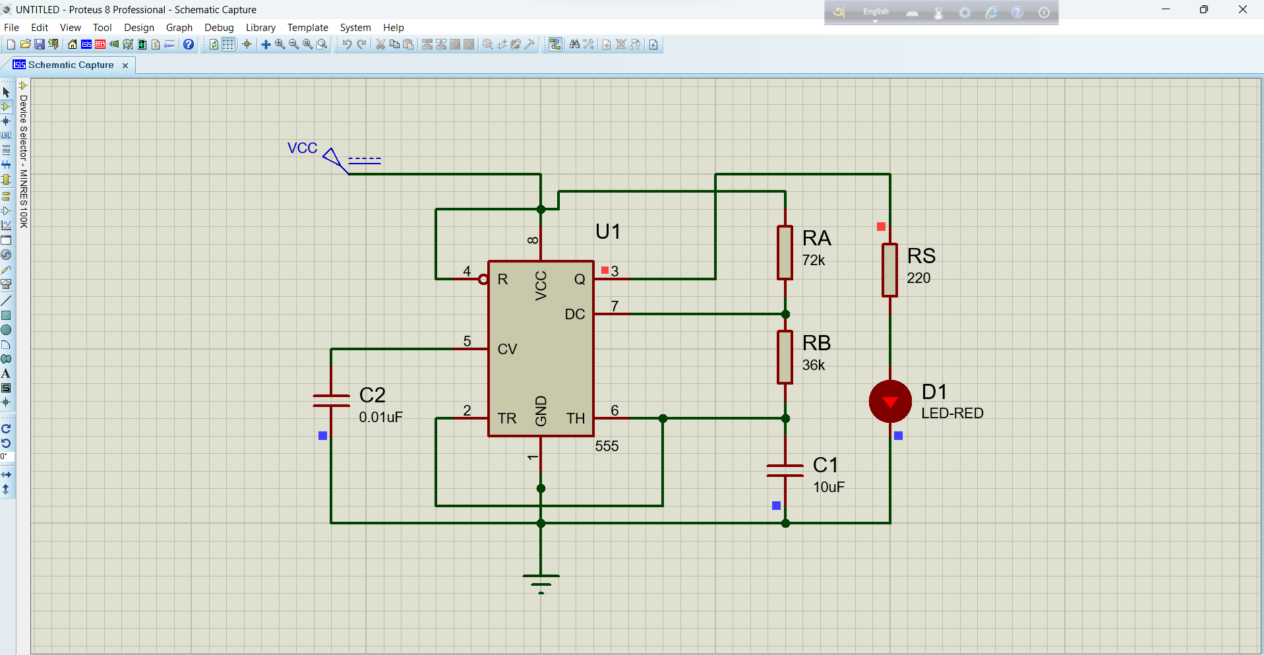

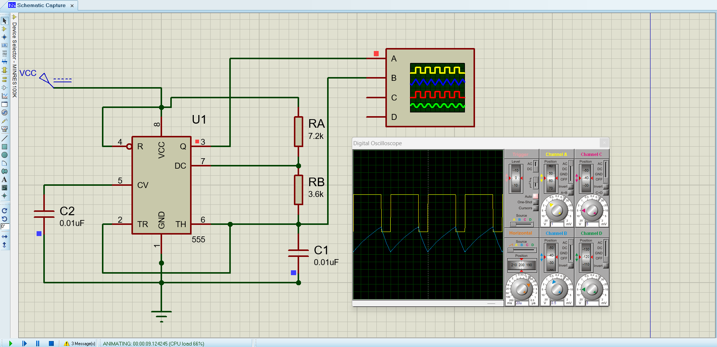

Monostable clock generator:
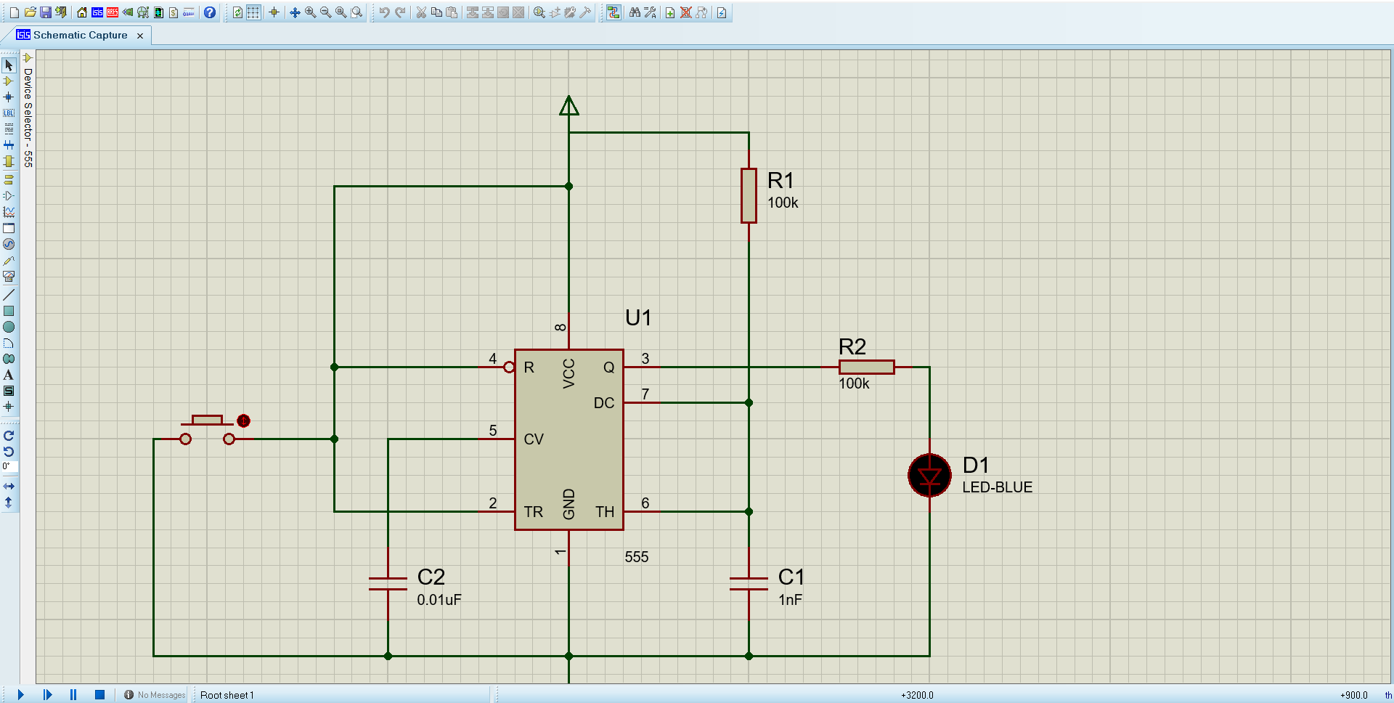

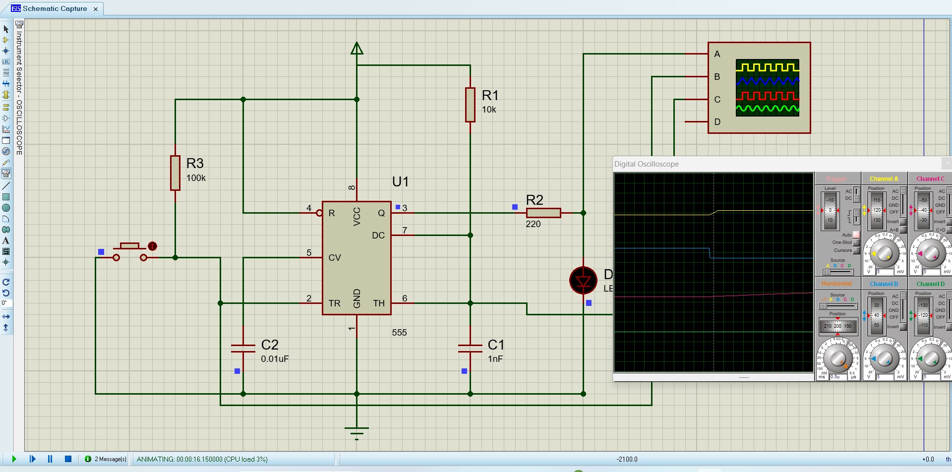

Bistable clock generator:
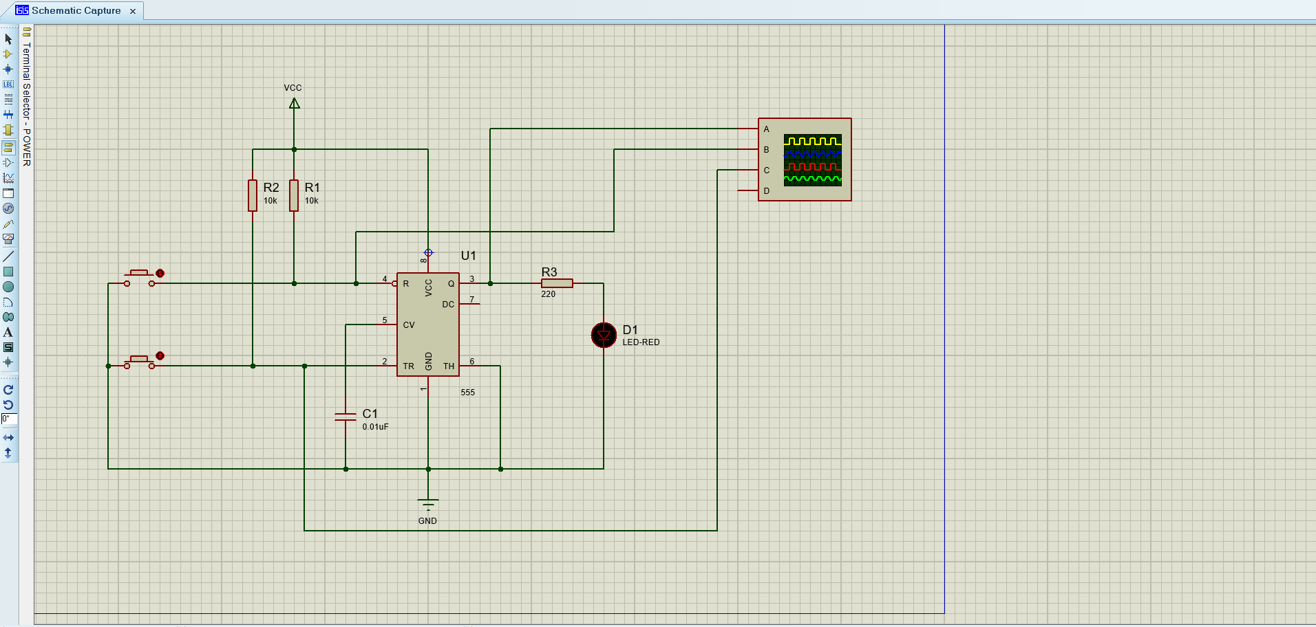
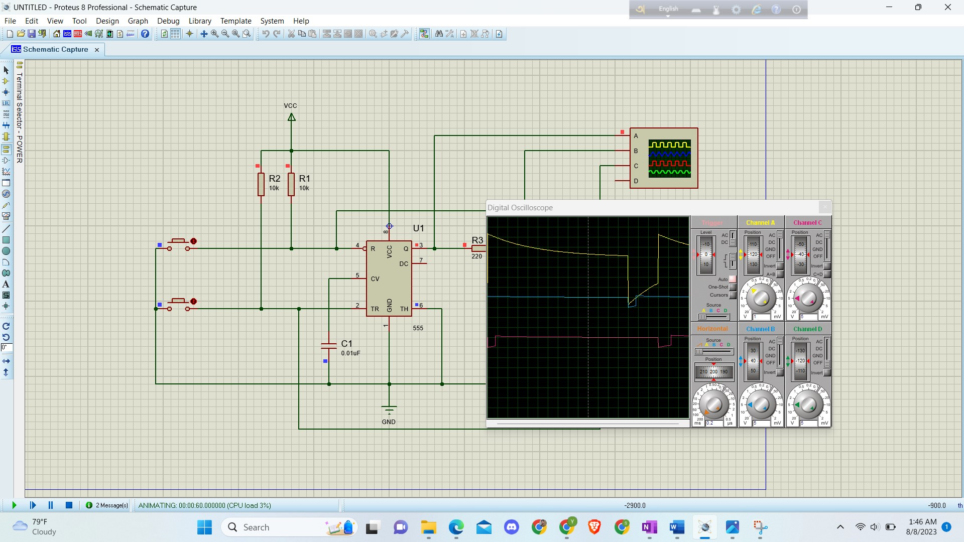

Simple Explanation of Connection:
The connections are mainly built with 555Timer IC, resistors, capacitors and ground. The shows some mechanism in this purpose.
The 555 Timer IC has two operational amplifiers, resistances, MOSFET as switch. Also, the clock generators have a capacitor to reduce noise and for continuous flow of current. According to voltage supremacy, current flows through the Op-Amps and the LED lights turns ON and OFF.
According to Oscillation diagram, we can observe the current flowing and discharging through the capacitor and LED.
Astable Mode Clock Timer has the continuous LED pulsing and its duration of ON and OFF can be changed by changing capacitance and resistance of the system according to these equations.
T_{ONN}=0.693(R_{A}+R_{B})x C₁ T_{OFF} = 0.693x R_{B} x C₁
Moreover, we can control simultaneously by adding a regulator to change the impedance.
Monostable mode has the mechanism to turn ON Light by push button. The ON duration of the LED light also can be varied by varying the impedance. After certain time the LED again turns OFF.

Bistable Mode has the combination of both of the Astable and Monostable mode. If we connect the IC according to the diagram, we get another formation of turning the LED lights ON and OFF. By one push button switch the other two can be controlled in different directions of ON or OFF.

